Name_________________________________ Date___________________

Geometry

Circle Vocabulary Practice

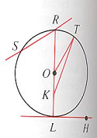For questions 1 – 9 use the accompanying diagrams. Be sure to use appropriate symbols

1. Name three radii of circle *O*.
2. Name a diameter.
3. Consider $\overline{RS}$ and $\overset{⃡}{RS}$. Which is a chord and which is a secant?
4. Why is  not a chord?
5. Name a tangent to circle *O*.
6. What name is given to point *L*?
7. Name two minor arcs.
8. Name two major arcs.
9. Name a semicircle.